Francisco Carrillo

English 2010-021

Identity Theft Report

"Every 79 seconds, a thief steals someone's identity, opens accounts in the victim's name and goes on a buying spree." (University of Colorado)

Identity theft is the use of an individual’s personal identifying information without his or her knowledge and with the intent to aid or abet in any unlawful activity such as the fraudulent obtaining of services, merchandise, money, and/or credit. These activities can easily be achieved by using information such as a person’s name, address, telephone number, birth date, Social Security number, Driver’s license number, passport number, health insurance policy number, financial account numbers, account passwords, biometric data, and e-mail address just to name a few. (Hoffman and McGinley 3).
People don’t ever think this will ever happen to them, but for experience it happens when least expected. It happened to me, luckily I was able to detect it early enough to cancel my card that was being used in Spain. It’s good to also know that this isn’t anything new. This kind of fraud started about 100 years ago. In the United States this was very uncommon until the early 1900s. One of the first theft cases was Cassie Chadwick. In1904 she was arrested after acquiring millions of dollars in bank and personal loans by falsifying trust agreements and by lying about being Andrew Carnegie's daughter and future heir. The industrialist/philanthropist who made his fortune in railroads and steel had no family ties to Chadwick. (Hoffman and McGinley 7).
The problem then became an issue, concerning people because it was way too easy for thieves to do. In August 14, 1935 President Franklin D. Roosevelt signed the Social Security Act, which assigned every American a Social Security number for life. (Hoffman and McGinley 13).The purpose of the act was to help restore economic security and to ensure stability in the future for the people. It was more like a hit and miss, because now days the Social Security number is greatly misused for theft. The U.S. Congress passed the Identity Theft and Assumption Deterrence Act in October 30, 1998 which made identity theft a Federal crime with penalties up to 15 years in prison and a fine of $250,000. Still the rate of crime keeps increasing. (Identity Theft Timeline).
In 2002 the FTC Federal Trade Commission logged 162,000 identity theft complaints, nearly double the amount in 2001. In 2003 the FTC released results of a survey that says 9.9 million people were victims of identity theft that year. Since 1977, the FBI counted 27.3 million identity theft victims in the U.S. In 2004, Approximately 7 million cases of identity theft were reported. In 2005 an FTC survey stated that 8.3 million American adults, or 3.7 percent of all American adults, were victims of identity theft. (Sourcebook of Criminal Justice Statistics). As the facts show, the number of victims has increased dramatically since 1977. They rate has been constant or increased, but not ones has decreased.
A Javelin/Better Business Bureau Survey found U.S. adult victims of identity theft decreased from 10.1 million in 2003 and 9.3 million in 2005 to 8.9 million in 2006, but the amount of losses rose from $53.2 billion in 2003 and $54.4 billion in 2005 to $56.6 billion in 2006. During 2003-2006 the number of victims decreased. (Sourcebook of Criminal Justice Statistics). Less people were getting hurt, but thieves were getting smarter and smarter with time. Now technology is getting very advanced and thieves are using that to their advantage. They were stealing higher quantities at once, to fewer victims. The survey also found that the mean amount per victim rose from $5,316 in 2003 and $5,993 in 2005 to $6,278 in 2006, and that the mean time for a resolution is at a high of 40 hours per victim in 2006 compared to 28 hours in 2005 and 33 hours in 2003.
By 2007, 7.9 million households in the U.S. had at least one member of the family fall victim to one or more types of identity theft. Here is a table with data that shows how much money in currency and percentage has been lost during those years.
Based on the table above this graph shows how much was lost each year and on what type of identity theft.
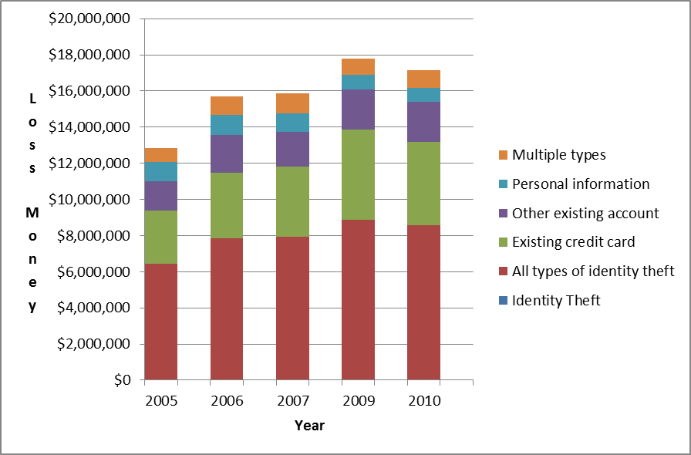
This chart shows the numbers from the table above. It’s an organized yearly graph with the different types of theft.

The graph above breaks down the entire household total to the types of identity theft in percentage.
There are other statistics that demonstrate that one gender is more likely to carry out a crime than the other, that age is a factor in identity theft, and also ethnicity. The “Sourcebook of Criminal Justice Statistics” contains that information. According to the statistics, more males than females are arrested and charged with committing crimes, the largest number of arrests occurred in the 15-24 year old age group, and that the majority of those arrested were Caucasian.
The rate of identity theft keeps increasing every year. One in every ten American consumers has been a victim of identity theft. Approximately 1.6 million households have had their bank accounts and/or debit cards compromised, nearly 50% of victims learn of their identities stolen within three months, and about 15% of victims don’t learn of their identities being stolen for four or more years. But all this can change; all that has to be done is learn how to protect oneself against Identity theft. For example, if there are very important documents that need to be disposed of, shred them. Install anti-virus software in the computer and update regularly, always secure digital information behind passwords, make sure to log off of any website that requires it, and monitor bank accounts at least weekly.
This is a very personal issue that needs to be taken care of. The theft is increasing at a steady pace. The ways and ideas of theft are always being renovated, and it has become easier for them to succeed. The internet is a big tool thieves use for identity theft. The use of social networks, free apps, and insecure web sites makes it easy for the world to obtain personal information at any time. For example Facebook, at any time anybody can go onto a random Facebook find out the person’s name, date of birth, the location where the person lives and where the person has been. Thieves can either hack into personal profiles to learn more about the person and/or they can just simply send an email with some sort of virus that will later make anything in the computer exposable to the world.
Always stay updated and aware of new ways that could damage financial assets and/or personal life. Never give information if asked over any media. When giving confidential information try to always do it in person, face to face.

Works Cited
Hoffman, Sandra K, Tracy G. McGinley. Identity Theft: A Reference Handbook. Santa Barbara, California:ABC-CLIO, 2010. Print
“Identity Theft Briefing Paper” University of Colorado. CU, 2013. Web. 05 Mar. 2013
ProQuest Staff. "Identity Theft Timeline." Leading Issues Timelines. 2013: n.p. SIRS Issues Researcher. Web. 06 Mar. 2013.
Sourcebook of Criminal Justice Statistics. University at Albany, 2013. Web. 05 Mar. 2013

