Name: Francisco Carrillo Section: Econ 2020 T-R 8:30
E-Portfolio – Signature Assignment
Salt Lake Community College
Macroeconomics - Econ 2020
Professor: Heather A Schumacker

Please type your answers to the following 5 questions. If you need to hand draw the graphs and then scan them in you may. When you have completed this assignment post it to your e-portfolio. Make sure to put your reflection statement on your web site. (4pts)

- What is the formula for PAE (write out the full name)? Circle the largest component and fill in the chart. Under each put the components and something unique. (19pts)

PAE = Consumption + Investment + Government + Net Exports
Components:  Circle the largest category | Components: | Components: | Components:
1.Durable goods | 1.Business Investment | 1.Goods | 1.Imports
2.Non-durable goods | 2.Residential Investment | 2.Services | 2.Exports
3.Service | 3.Inventory
 | Excludes:  1.Rinancial Assets,  Stocks and Bonds | Excludes:  1.Transfer payments  2.Interest on debt

- Given the following information, what is the short-run equilibrium output (show your work) ____1,305___ What is the autonomous expenditure ____1,305___ what is the induced expenditure ____.5y____ where would it cross the Y axis_____1,305____ what is the slope of PAE _____.5____ what is the multiplier _____2___ if there is a 10 unit increase in PAE what will happen to the short run equilibrium (increase or decrease)_____increase____ and by how much _____20_____ and will it lead to a recessionary gap or an expansionary gap____expansionary_____ (9pts)
C_{a} = 890 MPC = 0.5 I^{P} = 220 G = 300 X-M = 20 T = 250
PAE= 890+.5(y-250)+220+300+20 1/(1-.5)= 2 2*10=20
PAE=1305+.5y

- What is the problem associated with being at AD₂ that makes policy makers concerned? (1pt)
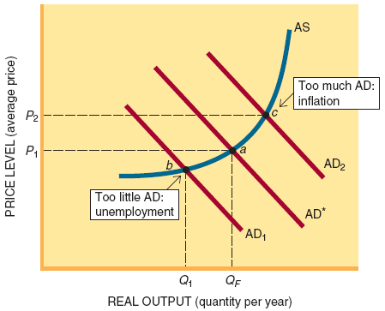
Inflation, due to tax cuts and Government spending

- Who does fiscal and monetary policy? What are 2 fiscal policies and 3 monetary policies to correct a situation where the economy is naturally at AD* but finds itself at AD₂, as seen in the graph on the previous page. Briefly explain how each of these policies would work to correct the situation. (12pts)
Who does fiscal policy: Congress and President
- Higher taxes
An increase in taxes will decrease spending
- Decrease Government Spending
Decrease in Government spending, increase corporate taxes and the consumers’ confidence to spend will decrease
Who does monetary policy: Federal Reserve
- Open Market Operation
Fed sells financial assets, the reserves decrease
- Reserve Requirement (rr)
Change the ratio; limit the amount banks may lend.
Increase reserve ratio, money multiplier will fall decreasing money supply
- Discount Rate
Increase discount rates so that borrowing reserves will be harder reducing excess reserve

- Begin in equilibrium in each of the following graphs; draw the effects from question 2 above as they would apply in each graph below. Next draw the effects of an anti-inflationary policy taken by the fed to correct the result from question 2 - use all three graphs (Money Supply and Money Demand, AD/AS, and PAE). Explain what is happening in each graph and overall in the economy as the due to the anti-inflationary policy. (20 pts)
Money Supply and Money Demand Graph

Nominal Interest Rate

Money Supply Curve (MS)

MS MS’

i

i’

M M’

AS

AD’

AD
Money Demand (MD)

The Fed will raise interest rates
Reduce autonomous expenditure
Short-run equilibrium output falls
The Fed decreases money supply, the supply of bonds increase which decreases the price as supply goes up and interest rates rise form i’ to i.
Higher interest rates decreases planned spending by households and firms

PAE
PAE

PAE = Y

PAE=1315+.5y

1315 PAE=1305+.5y

1305
45°

2610 2630 Y
Decrease consumer spending by 10 units which will bring back the potential to 2610

